Screenshots of the concepts I learned today-

1. Overview of the practical-

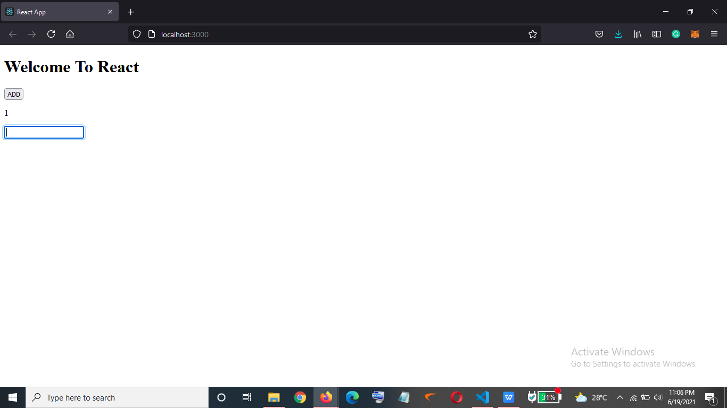

1. As we click on the ADD button the title on the website and the number below will get incremented

by 1 -

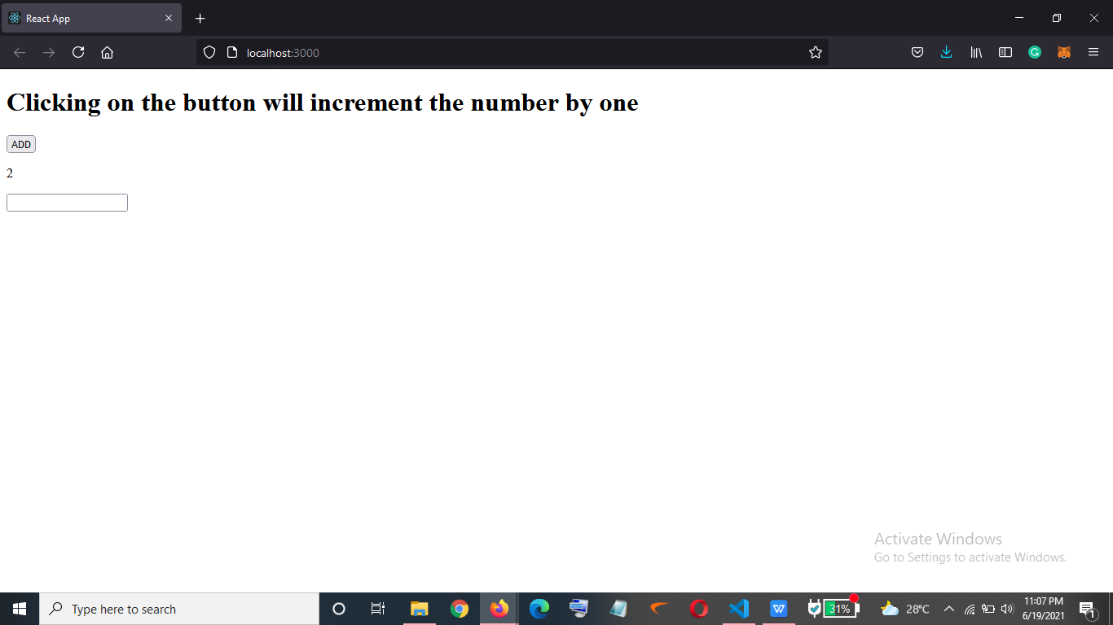

1. Whatever we type in the text-box will be displayed in the same manner below it in a ‘p’ text-

